

Briefing for Visitors - GUATEMALA
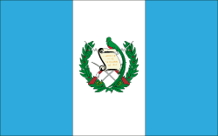
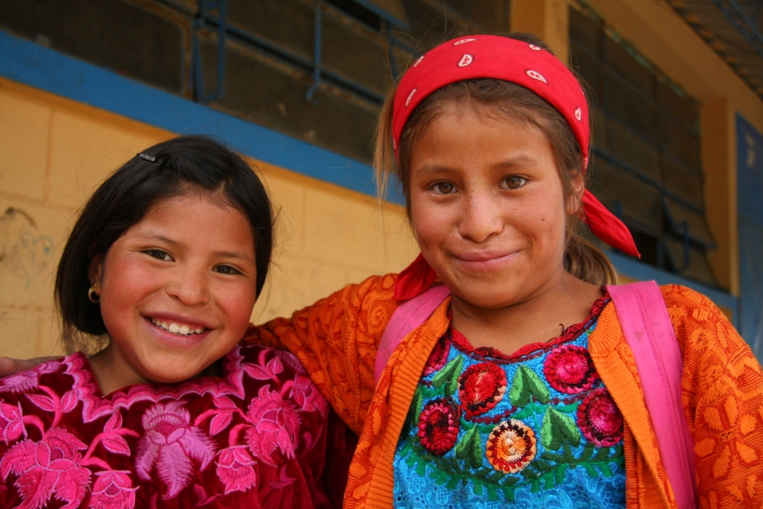Population: 14.7 million
Capital: Guatemala City
Languages: Spanish and 22 different Mayan languages, the Xinca and the Garifuna.
Currency: Quetzal (Q)
Exchange rate: Sale rate: Q.7.72 per US$1
Buy rate: Q.7.88 per US$1

Overview of the Country
Mountainous, heavily forested and dotted with Mayan ruins, lakes, volcanoes, orchids and exotic birds, Guatemala is one of the most beautiful countries in Latin America with a cultural diversity of 22 different Mayan groups and 24 languages.

Climate and Clothing
Guatemala has two seasons: the dry season from November to early May and the rainy season from mid-May to October. This does not mean that it rains all day long. There is usually sunshine in the morning and it rains for two hours or so in the afternoon or late in the evening. Guatemala City usually has a spring-like weather all year long 63°F (17°C) except from March to mid-May where temperatures can reach 76°F (24°C).

Clothing should be comfortable for travel and include shoes appropriate for walking, especially if traveling to the countryside. Regardless of the time of year, we recommend that you bring a jacket or a sweater for cool mornings or evenings and a windbreaker/rain coat during the rainy season.

Tremors
Guatemala is prone to frequent earth tremors and occasional earthquakes. Most tremors are barely felt as the epicenters are often located off the Guatemalan shores. Sometimes stronger tremors are felt, usually in the vicinity of 5 degrees on the Richter scale. Guatemala´s last major earthquake registering 7.5 on the Richter scale was in 1976. However, on November 7, 2012 a 7.2 earthquake was felt across the country and caused significant damage in the department of San Marcos and to a lesser extent Quetzaltenango and Totonicapán. If you experience a tremor, remain calm and leave the building. . If it gets worse, get under a door frame or table and cover your head. Stay away from windows and do not use the elevator.

Security
In recent years, Guatemala has been crippled by soaring levels of violent crime and impunity, which threaten the security of its population and seriously undermine the country’s institutions and state authority. To reduce the element of risk while in Guatemala, we recommend following these precautions:
      - Always be aware of what is going on around you, especially when walking or driving.
      - Avoid displaying items of value such as laptops, cameras and mobile phones and carry no more cash than is absolutely necessary.
      - Keep your eyes on your possessions, especially at bus stations, airports and crowded tourist places.
      - Avoid gatherings of agitated people. Although most demonstrations are peaceful, some can turn violent.
      - Keep away from unpopulated zones and poorly lit areas. Do not walk alone at night.
      - If you are in a car, keep all doors locked and windows closed and do not leave any valuables visible in the car.
      - When using ATMs, use those at closed facilities (inside a bank or a mall) and keep alert to people nearby. Do not accept help from strangers.
      - There have been a few reports of credit card cloning. Whenever possible, do not leave your card out of your sight when using it in restaurants and shops.
      - If you become a victim of any type of robbery do not resist or try to flee from robbers as you could put your life at risk.
      - There have been a few incidents in which foreign visitors have been unjustly suspected of malicious intentions against Guatemalan children. Do not to put yourself in any situation that might be misinterpreted and consult with CRS staff before close contact with children, including taking their photographs, especially in rural areas with predominantly indigenous populations.
      - Avoid taking public buses or hailing taxis on the street as a vast number of armed robberies take place on them. You can call Taxi Amarillo at 1766 or 2470-1515 or ask the CRS office or the hotel to arrange one for you.

Food and Water Precautions
- Tap water in Guatemala is not safe to drink. Drink only bottled water which is available everywhere.
- Avoid salads and do not eat food sold by street vendors.

Personal Documents
It is suggested that you carry a photocopy of your passport with you at all times and leave the original at the hotel. All travelers are encouraged to register with their respective embassies. The loss or theft of a foreign passport should be reported immediately to the local police and the respective embassy or consulate.

Places to go
Only one hour away from Guatemala City is Antigua Guatemala, a city with beautiful Spanish-style architecture and cobblestone streets built in the 16th century, ruined churches and monasteries (casualties of the 1773 earthquake) and a variety of outdoor cafes and restaurants. Another option for a day´s trip is Lake Atitlan surrounded by 12 villages and the amazing view of three volcanoes, located only 2.5 hours (by car) from Guatemala City.

Recommended Restaurants

In Guatemala City
Kakao  Guatemalan food  2a Ave. 13-44 zona 10 Phone: 23374188 | Tre Fratelli  Italian food  Plaza Fontabella  12 calle y 4ª. Ave, zona 10  Phone: 2420-5350 | Los Cebollines  Mexican food  12 calle 3-71, zona 10  Phone: 2360-1992 | Food Court  Oakland Mall (one block from CRS GT office)
In Antigua
Posada de Don Rodrigo  Guatemalan food  (with live marimba music at noon and from 7-9 p.m.)  Calle del Arco # 17.  Phone: 7832-9858 | Sabe Rico  Guatemalan food  6a. avenida Sur #7 Antigua Phone: 7832-0648 | El Tenedor del Cerro  Italian food  Cerro de Santa Inés, Antigua (with museums and a great view of Antigua)  Phone: 7820-1220 | Tartines  International food  (Cozy and served by a famous French Chef)  4a Calle Oriente #1C  Phone: 7882-4606

Emergency Contact List

Guatemala City Office  Diagonal 6 11-97, zona 10, Centro Inter  Naciones, Office. 201, Guatemala City,  Phone: (502) 2362-2173 | Anne Bousquet, Country Representative  Cell phone: (502) 5304-9441  Karen Latham, Head of Programming  Cell phone: (502) 5788-8003  Daniel McQuillan, Agriculture Program Manager. Cell phone: 5706-0368
Hotel Ciudad Vieja  8a. Calle 3-67 Zona 10, Guatemala City  Phone: (502) 2331-9104 http://www.hotelciudadvieja.com/ | Hotel Miralvalle (to be confirmed)  5a. Calle 2-43, Zona 4, 1, San Pedro Sacatepequez, San Marcos  Phone: 2444-4200
American Embassy
Avenida La Reforma 7-01, zona 10
Guatemala City Phone: (502) 2326-4000

Map of Guatemala

